
(An Autonomous Institution, Affiliated to Anna University, Chennai)
MINI PROJECT
IPL CRICKET DATA ANALYSIS AND VISUALIZATION USING POWER BI
Framework for Data Visual Analytics

Balamurugan S

241501032
ABSTRACT
This mini project, carried out for the subject Framework of Data Visualization and Analytics (FDVA), analyses the Indian Premier League (IPL) cricket dataset using Microsoft Power BI. The data is stored in two files: matches.csv, with 636 matches played between 2008 and 2017 and 18 columns, and deliveries.csv, with 150,460 ball-by-ball records and 21 columns. The files were loaded into Power BI, checked for data quality problems and linked into one data model. A one-page interactive dashboard was then built with four visuals: a bar chart of matches won by each team, a 100% stacked column chart of matches by season, a 100% stacked bar chart of matches by venue, and a line chart of the number of balls for each batting run value. The analysis showed that Mumbai Indians won the most matches (92), followed by Chennai Super Kings (79) and Kolkata Knight Riders (77). The 2013 season had the most matches (76), M Chinnaswamy Stadium hosted the most matches (66), and dot balls (61,148) were the most common outcome of a ball, followed by singles (55,497). The project shows how Power BI can turn raw match and ball-by-ball records into clear visuals that support cricket performance analysis.

Contents
1. Introduction and Objectives
2. Dataset Description
3. Data Preprocessing
4. Data Model
5. Power BI Dashboard
6. Insights from the Analysis
7. Limitations and Future Scope
8. Conclusion

1. Introduction and Objectives
The Indian Premier League is a Twenty20 cricket league that produces a large amount of data in every match: the teams, the toss, the venue, the winner and the result of every ball bowled. Raw tables of this kind are difficult to read directly. Data visualization makes it easy to see which teams win most often, how matches are spread over years and stadiums, and how batsmen score their runs.
This project uses Microsoft Power BI Desktop to analyse the IPL data from the 2008 to 2017 seasons. The main objectives are:
• Load and understand the matches and deliveries tables and the columns they contain.
• Check data quality by looking for missing values, duplicate rows and inconsistent team names.
• Build a data model that links match-level data with ball-by-ball data through the match id.
• Create an interactive dashboard that shows team wins, matches per season, matches per venue and the run-scoring pattern.
• Draw conclusions about team success, venue usage and batting that can support cricket analysis.

2. Dataset Description
The dataset has two related tables. The matches table has one row for each match, and the deliveries table has one row for each ball bowled. The two tables are connected by the match number (id in matches and match_id in deliveries). All 636 match ids in the deliveries table are present in the matches table.

Matches table (636 rows, 18 columns)
This table describes each match. The main columns are listed below.
Column | Description
id | Unique number of the match
season | Year of the IPL season (2008 to 2017)
city, venue | City and stadium where the match was played
date | Date of the match
team1, team2 | The two teams that played
toss_winner, toss_decision | Team that won the toss and whether it chose to bat or field
result, dl_applied | Result type (normal, tie, no result) and whether the Duckworth-Lewis method was used
winner | Team that won the match
win_by_runs, win_by_wickets | Margin of victory
player_of_match | Man of the match
umpire1, umpire2, umpire3 | Umpires of the match

Deliveries table (150,460 rows, 21 columns)
This table describes every ball. It covers 461 different batsmen across the 636 matches.
Column | Description
match_id, inning | Match number and innings (1 or 2; super overs are also marked)
batting_team, bowling_team | Teams batting and bowling
over, ball | Over number and ball number within the over
batsman, non_striker, bowler | Players involved in the delivery
batsman_runs | Runs scored by the batsman off the ball
extra_runs, total_runs | Extras (wide, bye, leg bye, no ball, penalty) and total runs on the ball
is_super_over | Whether the ball was bowled in a super over
player_dismissed, dismissal_kind, fielder | Details of a wicket, filled only when a wicket fell

Fields used in the dashboard
Table | Column | Used for
matches | id | Counting matches (Count of id)
matches | winner | Matches won by each team
matches | season | Matches in each season
matches | venue | Matches at each stadium
deliveries | batsman | Counting balls faced (Count of batsman)
deliveries | batsman_runs | Runs scored off each ball

3. Data Preprocessing
The two CSV files were loaded into Power BI Desktop using Get Data > Text/CSV and opened in Power Query Editor to check the data before building visuals. The loading step in Power Query is shown below.

Loading the data
let
Source = Csv.Document(File.Contents("matches.csv"),
[Delimiter=",", Encoding=65001]),
Headers = Table.PromoteHeaders(Source),
Typed = Table.TransformColumnTypes(Headers,
{{"id", Int64.Type}, {"season", Int64.Type},
{"winner", type text}, {"venue", type text}})
in
Typed
The same steps were used for deliveries.csv, with batsman_runs set as a whole number and batsman as text.

Missing values
Table | Column | Missing | Reason
matches | winner | 3 | Matches with no result (one in 2011, two in 2015)
matches | city | 7 | City not recorded for some matches
matches | umpire3 | 636 | Column is completely empty
deliveries | player_dismissed, dismissal_kind | 143,022 | Filled only when a wicket fell
deliveries | fielder | 145,091 | Filled only when a fielder was involved

Most missing values are expected: a ball without a wicket has no dismissal details. The empty umpire3 column is not used and can be removed. The three missing winner values appear in the first chart as one unnamed bar, which can be filtered out or labelled “No Result”.

Duplicates and inconsistent names
No duplicate rows were found in matches. In deliveries, one pair of identical rows was found (match 221, innings 1, over 4, ball 1), which is negligible among 150,460 records. A more important problem is team naming: “Rising Pune Supergiant” (10 wins) and “Rising Pune Supergiants” (5 wins) are the same franchise written in two ways, so they appear as two separate bars in the dashboard. They can be combined with a Replace Values step in Power Query.
Fixed = Table.ReplaceValue(Typed, "Rising Pune Supergiants",
"Rising Pune Supergiant", Replacer.ReplaceText, {"winner"})
After this step the franchise would show 15 wins in a single bar. All ball-by-ball records belong to a match in the matches table.

4. Data Model
Both tables were loaded into the same Power BI model, as seen in the model view. The matches table is connected to the deliveries table through the match number (matches[id] to deliveries[match_id]), which gives a one-to-many relationship: one match has many deliveries. This allows the match-level fields (season, venue, winner) and the ball-level fields (batsman, batsman_runs) to be used together and filtered together.
The report uses simple count measures created automatically by Power BI: Count of id (the number of matches) from the matches table and Count of batsman (the number of balls faced) from the deliveries table. Because every ball has one batsman, the count of batsman is the same as the number of balls bowled for each run value.

5. Power BI Dashboard
A one-page dashboard was built on a 1920 × 1080 canvas using four visuals. Clicking a bar or column in one visual filters the others where the tables are related, which makes the dashboard interactive.
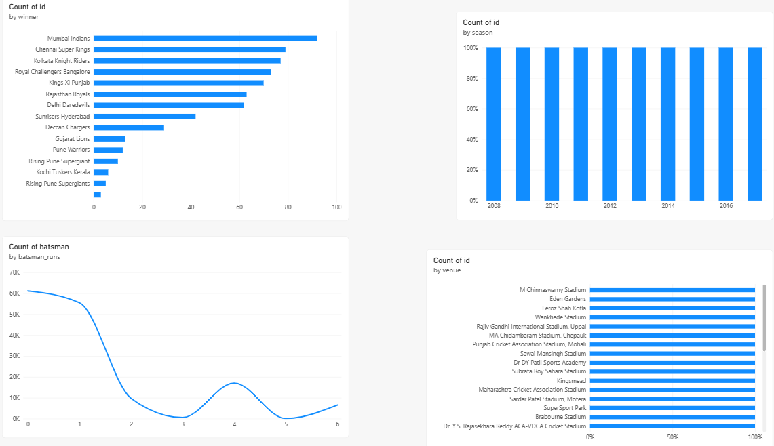
Figure 5.1: IPL Cricket Analysis Dashboard in Power BI

Visual 1: Matches won by each team (bar chart)
A horizontal bar chart shows the Count of id for each winner, sorted from the highest to the lowest. Mumbai Indians lead with 92 wins, then Chennai Super Kings (79), Kolkata Knight Riders (77), Royal Challengers Bangalore (73) and Kings XI Punjab (70). Teams that played fewer seasons, such as Kochi Tuskers Kerala (6), Pune Warriors (12) and Gujarat Lions (13), are at the bottom. The short unnamed bar at the bottom is the three no-result matches.

Visual 2: Matches in each season (100% stacked column chart)
This chart uses season on the axis and Count of id as the value, with one column for each season from 2008 to 2017. Because there is only one series in the chart, every column fills to 100%, so the chart shows which seasons are present but not how many matches each season had. The actual numbers are 58 matches in 2008, 57 in 2009, 60 in 2010, 73 in 2011, 74 in 2012, 76 in 2013, 60 in 2014, 59 in 2015, 60 in 2016 and 59 in 2017. A normal column chart, or a stacked chart with a field such as toss_decision in the legend, would show these differences clearly.

Visual 3: Matches at each venue (100% stacked bar chart)
This chart lists the stadiums on the axis and uses Count of id as the value. As in the season chart, one series makes every bar reach 100%. The stadiums are listed from the most used to the least used: M Chinnaswamy Stadium, Eden Gardens, Feroz Shah Kotla, Wankhede Stadium and Rajiv Gandhi International Stadium, Uppal. There are 35 venues in total, so the chart has a scroll bar.

Visual 4: Runs scored off each ball (line chart)
The line chart has batsman_runs (0 to 6) on the axis and Count of batsman as the value. The line starts at about 61,000 balls for 0 runs, falls slightly to about 55,000 for 1 run, drops sharply to about 10,000 for 2 runs, and reaches almost zero for 3 runs. It rises again to about 17,000 for 4 runs, falls to almost zero for 5 runs, and rises to about 6,500 for 6 runs. The shape shows that batsmen mostly score 0, 1 or a boundary, and rarely 3 or 5.

Dashboard features
• Interactivity: selecting a team, season, venue or run value highlights the related data in the other visuals.
• Sorting: the team and venue charts are sorted in descending order of the count.
• Layout: the team chart and run chart are on the left and the season and venue charts are on the right, so all four visuals are visible without scrolling.

6. Insights from the Analysis

Team performance
Team | Wins | Team | Wins
Mumbai Indians | 92 | Delhi Daredevils | 62
Chennai Super Kings | 79 | Sunrisers Hyderabad | 42
Kolkata Knight Riders | 77 | Deccan Chargers | 29
Royal Challengers Bangalore | 73 | Gujarat Lions | 13
Kings XI Punjab | 70 | Pune Warriors | 12
Rajasthan Royals | 63 | Rising Pune Supergiant(s) | 15

Mumbai Indians are the most successful team, with 92 wins out of 636 matches. The top three teams together won 248 matches. Mumbai Indians were also the top winner in the 2010, 2013 and 2017 seasons, and Chennai Super Kings in 2011 and 2015.

Seasons and venues
The league had 58 to 60 matches in most seasons, but 2011 to 2013 had more (73, 74 and 76) because ten teams played. 2013 had the most matches (76). Among the 35 venues, the five most used stadiums were:
Venue | Matches
M Chinnaswamy Stadium | 66
Eden Gardens | 61
Feroz Shah Kotla | 60
Wankhede Stadium | 57
Rajiv Gandhi International Stadium, Uppal | 49

These five stadiums are the home grounds of Royal Challengers Bangalore, Kolkata Knight Riders, Delhi Daredevils, Mumbai Indians and Sunrisers Hyderabad.

Batting pattern
Runs off the ball | Balls | Share
0 (dot ball) | 61,148 | 40.6%
1 | 55,497 | 36.9%
2 | 9,705 | 6.4%
3 | 509 | 0.3%
4 | 17,033 | 11.3%
5 | 45 | 0.03%
6 | 6,523 | 4.3%

Nearly four out of every ten balls produced no run, and about 77% of the balls produced 0 or 1 run. Fours (17,033) were more than twice as common as sixes (6,523). The batsmen with most runs in the data are SK Raina (4,548), V Kohli (4,423), RG Sharma (4,207), G Gambhir (4,132) and DA Warner (4,014).

Other observations
• Toss: teams that won the toss won the match in 325 of 636 matches (51.1%), so the toss gives only a small advantage. Teams chose to field first in 363 matches and bat first in 273.
• Results: 626 matches had a normal result, 7 were ties and 3 had no result.

7. Limitations and Future Scope

Limitations
• Chart type: the season and venue charts are 100% stacked charts with a single series, so every bar is full length and the differences in the counts are not visible.
• Team names: Rising Pune Supergiant and Rising Pune Supergiants are shown as two teams, and the three no-result matches appear as an unnamed bar.
• Time period: the data covers only the 2008 to 2017 seasons.
• Line chart: the run values are separate categories, so a column chart would describe them better than a smoothed line.

Future scope
• Replace the single-series 100% charts with normal column and bar charts, or add toss decision or result to the legend.
• Add slicers for team, season and venue, and KPI cards for total matches, total runs and number of venues.
• Add a top run-scorers chart, a bowler analysis from the dismissal_kind column, and a toss-and-win analysis.
• Add a map of the host cities and update the data with later seasons.

8. Conclusion
In this project the IPL matches and deliveries data (636 matches and 150,460 balls) was loaded, checked and linked in Power BI, and a four-visual interactive dashboard was created. The dashboard shows that Mumbai Indians are the most successful team with 92 wins, that matches are spread over 35 venues with M Chinnaswamy Stadium used most, that the 2011 to 2013 seasons had the most matches, and that most balls produce either no run or a single run, with fours more common than sixes. The project also showed the importance of data checking, such as finding the two spellings of one team name, and of choosing the right chart type for the message. The dashboard can be improved with slicers, KPI cards and further batting and bowling analysis.

References
Microsoft Power BI Desktop documentation, https://learn.microsoft.com/power-bi/
IPL matches and deliveries dataset (matches.csv and deliveries.csv), seasons 2008 to 2017.

